Minor Project Report on

**E-Learning Platform**



in partial fulfillment for the award of the degree of

Bachelor of Information Technology Engineering

**Submitted By**

Abhinav Tamrakar [22120106]

Bam Bahadur Karki [22120113]

Hemant Khadka [22120123]

Parikshit Bhandari [22120130]

**Submitted to**

Department of Computer/ IT/ Software Engineering

Everest Engineering College

Sanepa-2, Lalitpur

**June, 2025**

# ACKNOWLEDGEMENT

We would like to express our sincere gratitude Everest Engineering College, affiliated with Pokhara University, for providing the necessary resources and a conducive environment for learning and development.

We would also like to express our sincere gratitude to our mentor, Er. Santosh Bist for his valuable suggestions, constant encouragement, and insightful feedback which helped shape the direction of this proposal. Their guidance has been essential in identifying the project objectives, scope, and implementation strategy.

Finally, we extend our appreciation to our families and friends for their constant encouragement and motivation.

# ABSTRACT

The rapid advancement of digital technology in education has created opportunities for more interactive and accessible learning environments. This project outlines the development of an E-Learning Platform a web-based platform that enables students to take course-related quizzes online, track their performance, and engage in self-assessment.

The platform will provide essential features such as user registration, login, quiz-taking functionality, automatic score calculation, and result history. An administrative interface will allow educators to create and manage courses and quizzes dynamically.

The implementation of this project will demonstrate the practical application of web development and database management concepts while contributing to the growing field of digital education.

**Table Of Contents**

**ACKNOWLEDGEMENT i**

**ABSTRACT ii**

**LIST OF FIGURES v**

**LIST OF TABLES vi**

**Chapter 1: INTRODUCTION 1**

1.1 Background 1

1.2 Problem Statement 2

1.3 Objective 2

1.4 Scope 2

1.5 Application 2

1.6 Hardware and Software Requirements 3

**Chapter 2: LITERATURE REVIEW 4**

2.1The Impact of Technology Integration on Student Learning Outcomes: A Comparative Study 4

2.2 Analysis of Students’ Behavior on Moodle Platform During Evaluation Using Data Mining Techniques 4

2.3 The role of gamified e-quizzes on student learning and engagement: An interactive gamification solution for a formative assessment system 4

2.4 The Effect of In-Lecture Quizzes on Student Engagement and Learning in Online Classes 5

2.5 ELPID (E-learning Platform for Innovative Product Development) 5

Chapter 3**:** METHODOLOGY 6

3.1 Introduction 6

3.2 SRS Diagram 6

3.2.1 Description of SRS Diagram 7

3.3 Methodology 7

3.3.1 Phases of the spiral model 7

3.4 Flowchart 9

3.4.1 Description of Flowchart 10

3.5 Use Case Diagram: 11

3.5.1 Description of Use Case Diagram: 12

**Chapter 4: Result and Analysis 13**

4.1 Outcome Summary 13

4.2 Comparison with Traditional Methods 14

4.3 Conclusion of Analysis 14

**Chapter 5: Conclusion and Future Enhancements 15**

5.1 Conclusion 15

5.2 Future Enhancements 15

**REFERENCES 16**

**APPENDIX 17**

# LIST OF FIGURES

Figure 3.2: SRS Diagram of E-learning Platform 6

Figure 3.3.1: Spiral Methodology……………………...………………..…………………8

Figure 3.4: Flowchart of Quiz Game 9

Figure 3.5: Use Case Diagram of E-learning Platform…………………………… …..…11

# LIST OF TABLES

Table 4.2.1: Schedule of Remaining Works 14

# Chapter 1: INTRODUCTION

## 1.1 Background

In today’s digital learning environment, interactive and engaging content plays a crucial role in effective knowledge acquisition. Traditional text-based learning often lacks the ability to assess whether readers have comprehended the material.

The pace at which material increases on the internet has transformed the way people are consuming information, particularly in education, training, and self-learning. Reading reports and articles is a common way of transferring information, but one of the biggest challenges is to ensure that users are reading and understanding the materials they are being presented with. Simply having content available isn’t enough anymore — user interaction and understanding verification are essential to make learning effective.

In order to address this issue, we designed an online application that encourages users to read an article and then interact with interactive quizzes later. The central idea is to encourage users to read an article thoroughly and measure their knowledge through a sequence of multiple-choice questions on the article.

This system is built using the PHP for server-side development, HTML and CSS for client-side, and MySQL as the relational database to store users, articles, and quiz information.

Users must first login in order to be capable of using the system. Once they are logged in, they can view various articles which have been published by the administrator or writers. Each article is accompanied by five matching quiz questions, and the quizzes are inaccessible until the reader has scrolled through the article entirely — simulating actual reading involvement. This application is designed for educational platforms, e-learning portals, corporate training environments, or any content-based system where reading comprehension needs to be verified. By combining reading with evaluation, it encourages active learning and helps administrators measure the effectiveness of their content.

## Problem Statement

Modern web-based learning platforms often provide reading material followed by quizzes to evaluate user comprehension. However, a significant gap exists in ensuring users actually engage with the content before attempting the quiz. The problem lies in the lack of integration between content delivery and assessment control. A system is needed that not only delivers articles but also ensures they are completely read before unlocking quiz access, thereby improving comprehension, engagement, and learning effectiveness.

## Objective

To Develop a system that delivers articles but also ensures they are completely read before unlocking quiz access.

## Scope

The E-Learning Platform aims to enhance the learning experience by providing users with educational content and quizzes. The scope of this project includes:

* Article Management:
* Admins can add new articles with titles and detailed content.
* Articles will be listed on the dashboard for users to read.
* Quiz Integration:
* Each article has exactly 5 multiple-choice questions stored in the database.
* Users can take the quiz only after reading the article.

## Application

* Corporate Training and Onboarding: Ideal for training employees on company policies, safety guidelines, or compliance documents.
* Online Journals and Research Portals: Academics or researchers can publish articles and add quizzes to test understanding or validate knowledge of readers.
* Skill Development Courses: Used in skill-based learning apps or portals where users learn a concept (e.g., coding, marketing, writing) and then take a short quiz for reinforcement.
* Knowledge Retention Tools: Can be used in workshops, webinars, or conferences to ensure participants retain what they’ve read or learned from event materials.
* Self-paced Learning Systems: Perfect for learners who wish to study articles independently and test their understanding on the go.

## Hardware and Software Requirements

1. Hardware Requirements:

* RAM – 4 GB
* CPU – Intel core i5 (7th gen)
* SSD – 256 GB

1. Software Requirements:

* Operating System – Windows 10
* Programming Language – CSS-3, HTML-5, JavaScript, PHP
* IDE – Visual Studio Code
* Database – MySQL
* Local server: Xampp

# Chapter 2: LITERATURE REVIEW

## The Impact of Technology Integration on Student Learning Outcomes: A Comparative Study

A study was conducted by Krenare Pireva Nuci, Rabail Tahir, Ali Shariq Imran, and Alf Inge Wang in 2020 investigated the effect of in-lecture quizzes in online classes and the correlation of students’ learning curve over four months. It was found that there was a significant increase in students’ engagement and interaction levels in lectures with systematic in-lecture quizzes. Furthermore, it was observed that the learning curve was steeper when in-lecture quizzes were used (73%) compared to classes where in-lecture quizzes were not used (57.5%) [1].

## 2.2 Analysis of Students’ Behavior on Moodle Platform During Evaluation Using Data Mining Techniques

A study was conducted by Zamfiroiu Alin, Radu Boncea, and Ionut Petre in 2019 on the use of mobile technologies in the learning environment to bring education closer to students. A large number of educational materials and content was being produced by teachers for mobile applications. This content was either stored on mobile memory or accessed through cloud technologies, with mobile applications being used solely to retrieve data from the cloud. The content was becoming significantly large, allowing it to be classified as Big Data. Additionally, students’ activities on the applications were logged, with each action undertaken by the students being recorded and saved in a database. These logs were analyzed to predict students’ evolution. Furthermore, based on the analysis of these logs, teaching methods could be improved and adapted to students’ needs. In this paper, the logs of students’ activity in a quiz on the MOODLE platform were analyzed to observe their behavior [2].

## 2.3 The role of gamified e-quizzes on student learning and engagement: An interactive gamification solution for a formative assessment system

A study was conducted by Zamzami Zainuddin, Muhammad Shujahat, Hussein Haruna, and Samuel Kai Wah Chu in 2019 to investigate the differences in learners’ performance and perceived engagement between three intervention groups in a science class, using two types of pedagogical intervention: traditional instruction with paper-based quizzes and gamified instruction with gamified e-quizzes as formative assessments. It was shown in their study that applying games or game concepts in the classroom could be seen as a promising and innovative tool for engaging students in creative learning skills and attractive competition [3].

## 2.4 The Effect of In-Lecture Quizzes on Student Engagement and Learning in Online Classes

A study was conducted by Bello Alhaji Buhari and Abubakar Roko in 2017, which focused on the design and implementation of an improved e-learning system, using the Computer Science Unit of the Mathematics Department at Usmanu Danfodiyo University, Sokoto as a case study. Learning materials were allowed to be uploaded online, and a platform was provided for one-on-one interaction with lecturers by creating an avenue for students to ask questions and receive answers online. The system was intended to be user-friendly, reliable, and enhanced with improved specifications. The e-learning system was designed using HTML, CSS, PHP, Ajax, and MySQL. To ensure effective interaction between students and lecturers, audio calls to lecturers through Skype and video conferencing via webinar software were incorporated, enabling live lecture delivery. This gave the system the ability to provide, receive, and discuss information in real time [4].

## 2.5 ELPID (E-learning Platform for Innovative Product Development)

An e-learning platform for virtual project-based design courses, called ELPID (E-learning Platform for Innovative Product Development), was proposed in the conference paper “E-learning infrastructure prototype for geographically distributed project-based learning.” The basic theoretical project background was required to be covered through textual, audio, and video materials (lectures and tutorials). Furthermore, virtual and digital technologies were to be integrated into the platform to provide students with opportunities for collaborative and creative problem-solving [5].

# Chapter 3: METHODOLOGY

## Introduction

The methodology for developing the E-Learning Platform follows a structured and modular approach, encompassing front-end design, back-end development. This approach ensures that each component of the system functions cohesively to provide seamless and efficient user experience. The primary objective is to build a dynamic, user-friendly web application that help enhance students learning ability.

## SRS Diagram

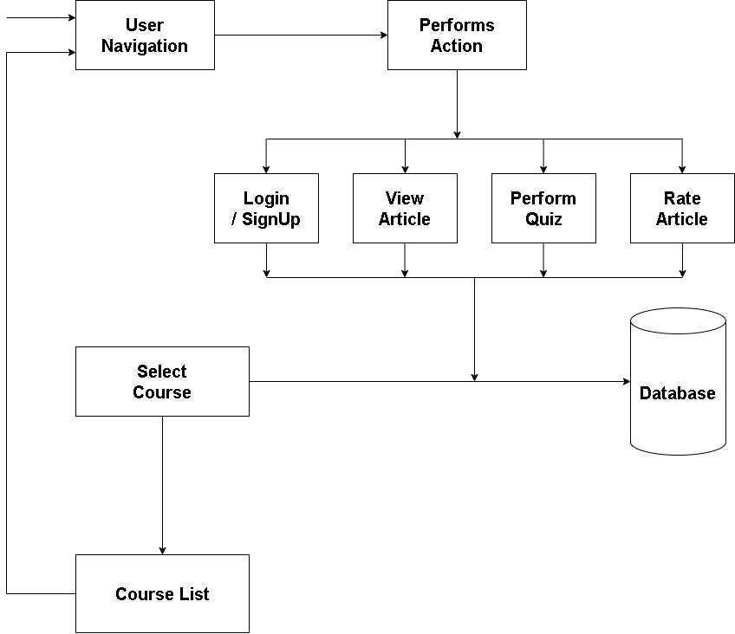

Figure 3.2.1: SRS Diagram of E-learning Platform Architecture

### Description of SRS Diagram

This block diagram illustrates the workflow of a E-Learning Platform. Let’s go through each block step-by-step:

* + - User Navigation
* This block represents user activity or behavior on a platform.
* It initiates the process, feeding data into the system when a user starts navigating through the platform.
  + - Perform Actions
* After navigation, the user performs various actions on the site.
* These actions are crucial in understanding user preferences.
  + - Action Types

These represent specific interactions a user can have with a product:

* + Login/ Sign-up – The user login or sign-up.
  + View Article– The user can view and read the articles.
  + Rate Article – The user gives an article a rating (e.g., 4 stars).
  + Perform Quiz– A strong positive signal, indicating purchase behavior.
    - Select Courses:
* Users can select the courses they want to study.
* Database
* Stores the data into the database

## Methodology

The development of the Article-Based Quiz Web Application follows the Spiral Model, a risk-driven process model that combines elements of both design and prototyping in stages. The Spiral Model emphasizes iterative development and allows for frequent reassessment of risks and requirements throughout the project lifecycle.

### Phases of the spiral model

A. Planning phase:

* User registration
* Article posting
* Quiz access control

B. Risk Analysis Phase

* User skipping article reading before quiz.
* Improper session handling.
* SQL injection

C. Development Phase:

* User registration and Session management.
* Upload article and view.
* Scroll-detection based quiz unlocking.
* Quiz retrieval from the database

D. Evaluation Phase:

* Regularly test each module with:
* Unit Testing:
* Integration testing.
* UI testing.

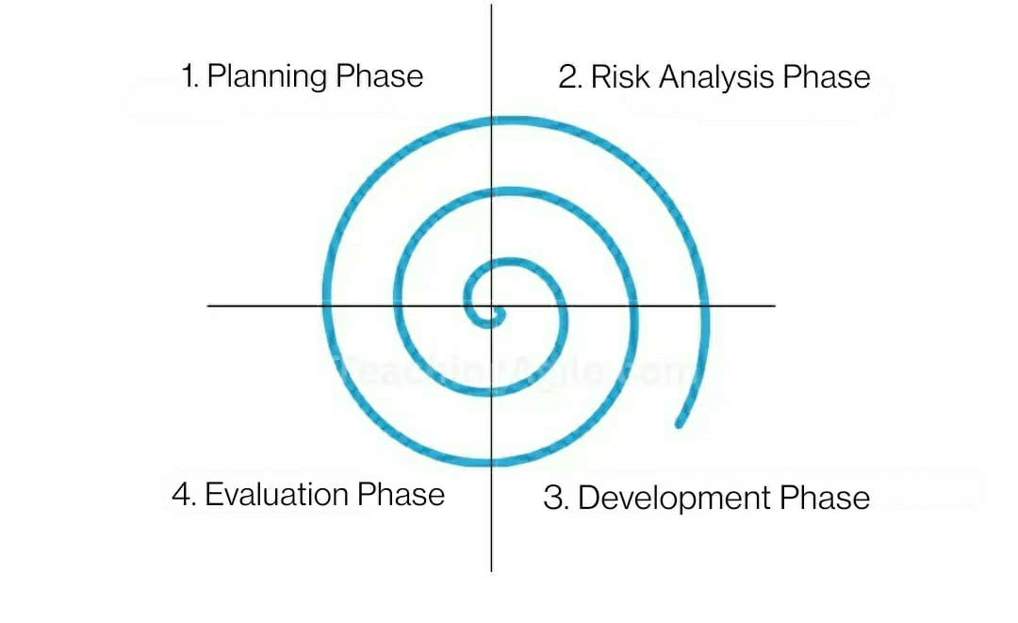

Figure 3.3.1: Spiral Methodology

## Flowchart

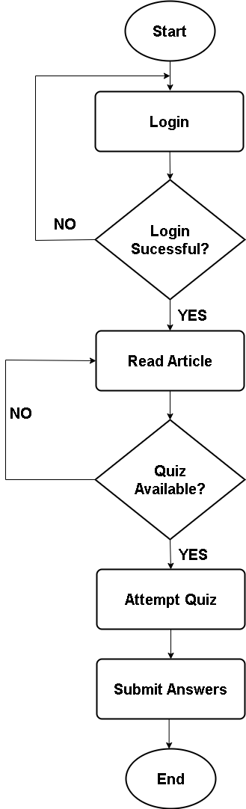

Figure 3.4: Flowchart of Quiz Game

### Description of Flowchart

The following steps are required to operate the product recommendation system: -

* Start: User opens the website.
* User Logs in.
* Login Successful?
  + If yes, Read article.
  + If no, back to login page.
* Quiz Available:
  + If yes, Attempt Quiz.
  + If no, Read article.
* Submit Answers.
* End: This cycle concludes after action or inactivity.

## Use Case Diagram:

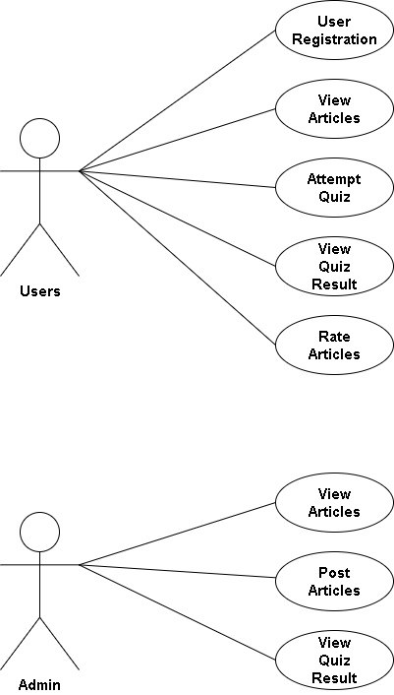

Figure 3.5: Use Case diagram of E-learning Platform

### Description of Use Case Diagram:

The Use Case Diagram visually represents the interactions between users and the system. It highlights the functionalities available and who can perform them.

1. Actors:
   * User: A regular user who reads articles and takes quizzes.
   * Admin: Can post articles and add quizzes
2. Use Cases:
   * User registration: Authenticate the users.
   * View Articles: Display a list of articles.
   * Attempt Quiz: Becomes available only after the article is completely read.
   * Post Article (Admin): Allows admin to add new articles.
   * View Quiz Results: Allows both users and admins to view results.
   * Rate Article (User): Users can rate the article as they like. (e.g. 4 stars)

# Chapter 4: Result and Analysis

## Outcome Summary

The E-learning Platform was successfully implemented using HTML, CSS and JS for frontend, PHP for backend and MySQL for database. Upon completion, the system demonstrated following:

1. Functional user registration and Session handling:

* Users and Admins can register and Login successfully.
* The data were successfully recorded on our database.

1. Article retrieval and display from the database:

* Articles were displayed dynamically and was successful.

1. Scroll-based detection:

* Scroll-based detection to enforce full article reading was implemented successfully.

1. Controlled Access to quizzes:

* Access was given to admins to edit and/or update the quizzes.

1. Friendly UI:

* A clean, navigable interface that supports user interaction was successfully implemented.
* The system ensures user authentication before accessing quizzes.

These outcomes were met accordingly to the core objective of ensuring user engagement with content before evaluation.

## Comparison with Traditional Methods

|  |  |  |
| --- | --- | --- |
| Feature | Traditional Quiz System | E-Learning Platform |
| Quiz Accessibility | Immediately available | Restricted until article is read |
| User Authentication | Optional or Weak | Mandatory Login |
| Feedback loop | Often missing | (To be added) Results module |
| User Engagement | Low | High, due to content lock-in |

Compared to the traditional systems, this platform gives us added layer of intentional engagement and it offers a practical improvement without requiring expensive resources.

## Conclusion of Analysis

This platform demonstrates clear advantages in promoting learning effectiveness, structured content promotion, and user flow control by ensuring users engage with articles before accessing quizzes, it transforms passive assessment into an active learning process.

# Chapter 5: Conclusion and Future Enhancements

## Conclusion

The E-Learning Platform web application was developed to address a common challenge in digital learning platforms which was that the users often skip the educational content and directly attempted quizzes without properly engaging with the materials.

Using HTML/CSS/JavaScript for user interface integration, PHP for backend logic and MySQL for storing database, a fully functional web application was developed successfully. The system enables users to securely login, access articles and attempt quizzes that are linked with the reading materials.

This project effectively tackled the traditional learning problem by introducing a scroll-based lock mechanism that ensures users read the article in full before attempting the quiz. It also contributed valuable insights into combining user interface behaviour with educational logic to enforce learning discipline.

## Future Enhancements

While this project successfully achieved its primary goals, several limitations and growth opportunities were identified that can be addressed in future iterations:

* Addition of timers or progress bars during quizzes to simulate real test conditions.
* Search and filtering option for articles-based topics.
* Adaptable for mobile platforms.
* Applying responsive design frameworks like Bootstrap to improve UI aesthetics.
* Add result feedback.

# 

# REFERENCES

[1] K. P. Nuci, R. Tahir, A. I. Wang and A. S. Imran, "Game-Based Digital Quiz as a Tool for Improving Students’ Engagement and Learning in Online Lectures," in IEEE Access, vol. 9, pp. 91220-91234, 2021, Doi*/*: 10.1109/ACCESS.2021.3088583.

[2] Alin, Zamfiroiu & Petre, Ionut & Boncea, Radu. (2019). Quiz logs analyze on Moodle E-Learning platform.

[3] Zamzami Zainuddin, Muhammad Shujahat, Hussein Haruna, Samuel Kai Wah Chu Year: 2020 Container: Computers and Education Volume: 145 Issue: 1 Page: 103729 DOI: 10.1016/j.compedu.2019.103729

[4] Buhari, Bello & Roko, Abubakar. (2017). An Improved E-Learning System. Saudi Journal of Engineering and Technology. 2. 114-118. 10.21276/sjeat.2017.2.2.5.

[5] L. Grindei and M. Bulgaru, "Design of an e-Learning platform in the field of Innovation Management for engineers," 2011 Proceedings of the 22nd EAEEIE Annual Conference (EAEEIE), Maribor, Slovenia, 2011, pp. 1-6

# APPENDIX



